**System Design**

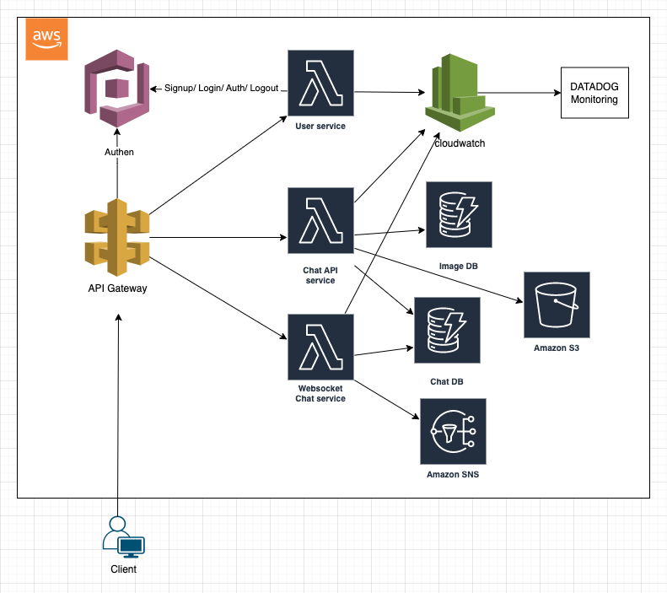

I will design this system base on AWS serverless lambda framework for easy scaling and fully cloud managed of Infrastructure.

Regarding authentication/user service, I will use AWS Cognito. System will have lambda function for user to register/login/logout and it will call to AWS Cognito to managed the user and do authenticate.

Regarding Chat API service, I will use lambda function with DynamoDB, S3 to store image/document. Image/Document will be store in S3 and its data (document url, coordinate of anotations) will be store in ImageDB.

Regarding Websocket Chat Service will be use for managed connection and realtime comunications. If client of the topic doesn’t connected so the message will be send via SNS (APNS, FCM, PushNub, Onesignal, ...).

For systems logs i will use cloudwatch and datadog for monitoring.

Techstack:

- Typescript.

- AWS.

- DynamoDB: <https://aws.amazon.com/dynamodb/>

- Serverless Framework: <https://www.serverless.com/>

- Datadog: <https://www.datadoghq.com/>